An Examination of the Relationship of Yellowstone Wolf and Elk Populations
Shannon Keeney

After wolves were extirpated in Yellowstone National Park in 1926, herbivores, like elk, lost a natural predator. Elk would overgraze vegetation in some areas of the park. This led to the erosion of streams and lack of food and shelter for other species that depended on plant growth. The reintroduction of wolves in 1995 and 1996 was important to help manage the elk population. The reintroduction of the predator greatly improved the grazing impact of elk in Yellowstone since wolves manage elk populations better than resource availability. Without wolves, elk would eventually reach their carrying capacity in the ecosystem. Yellowstone used to be home to about 20,000 elk but the abundance has fallen to as few as 5,000 since the reintroduction. (Smith et al., 2020).
The purpose of this project is to examine the relationship between the Yellowstone wolf population and the elk population. This project will compare the predicted elk count to the population count of wolves to see if there is a correlation between the two or if population trends are found.
The population counts are the average for each year between 1995 and 2022. Although, this data was collected based on the mortality of a Yellowstone wolf, it created clearer graphs to use the average.

Cassidy et al., 2024
Graph 1 shows the average wolf count (WC) and the predicted elk count (PED) (10^-3) from 1995 to 2022, the left y-axis is for the wolf count, and the right y-axis is for the predicted elk count. The populations stabilize in 2009. The dotted lines are trendlines.
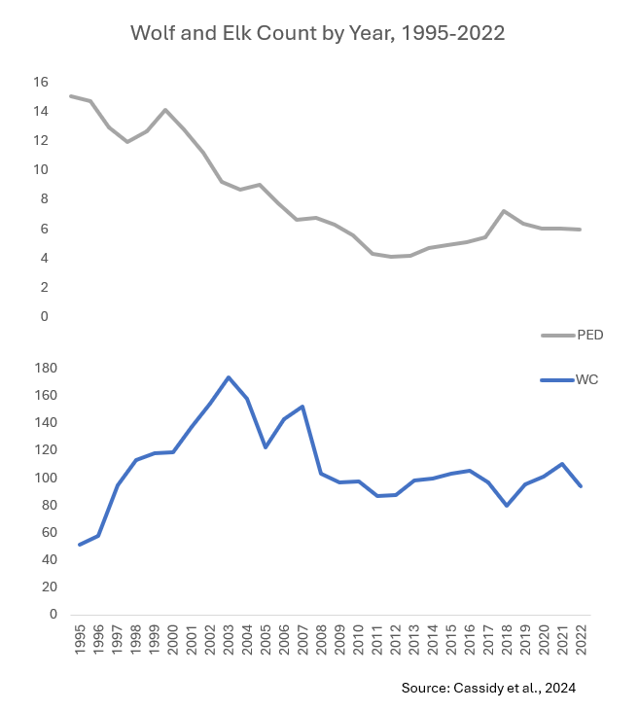
Graph 2 shows the average wolf count and the predicted elk count (10^-3) from 1995 to 2022 on two graphs with the same x-axis and 2 y-axis. This allows the wolf and elk count to be properly scaled while also being compared. It shows that after Yellowstone wolves were reintroduced, the elk population has been on a downward trend. It also shows that after small spikes in the elk population that there is also a small spike in the wolf population. Which then is followed by a small decrease in both populations. Both populations stabilized in 2009 and have had small fluctuations since then.
Source
Cassidy, B., Smith, D. W., Cassidy, K., Stahler, D., & Hebblewhite, M. (2024). Harvest of
transboundary gray wolves from Yellowstone National Park is largely additive. Journal of Applied Ecoloy, 61(9), 2180–2193. https://besjournals.onlinelibrary.wiley.com/doi/full/10.1111/1365-2664.14720
Smith, D. W., Stahler, D. R., & MacNulty, D. R. (2020). Yellowstone Wolves: Science and
Discovery in the World’s First National Park. University of Chicago Press.

